Power Requirements:

1. PZEM-004T (Metering Module)
- Description: Measures voltage, current, power, and energy consumption.
- Operating Voltage: 80-260V AC
- Current Measurement: Up to 100A
- Power Consumption: Approximately 0.5W
- Key Features: High precision, real-time monitoring.

2. ESP32 WROOM 32 (Microcontroller Unit)
- Description: A versatile MCU with Wi-Fi and Bluetooth capabilities.
- Operating Voltage: 3.3V
- Peak Current: Up to 160mA during Wi-Fi operation
- Power Requirement:
P = V × I = 3.3 V × 0.16 A = 0.528W
- Key Features: Dual-core processor, integrated peripherals.

3. DS3231 (RTC Module)
- Description: Real-time clock with temperature compensation.
- Operating Voltage: 3.3V to 5V
- Current Requirement:
  - Battery mode: 0.1µA
  - Active mode: 1-2mA
- Power Requirement (worst case):
P = 5 V × 0.002 A = 0.01 W

4. AT24C256 (EEPROM Module)
- Description: 256K I2C EEPROM for data storage.
- Operating Voltage: 1.8V to 5.5V
- Current Requirement: Approximately 1mA
- Power Requirement:
P = 5 V × 0.001 A = 0.005 W

5. 20x4 LCD (Liquid Crystal Display)
- Description: Displays information in a 20x4 character format.
- Operating Voltage: 5V
- Current Requirement: Approximately 2-20mA
- Power Requirement:
P = 5 V × 0.02 A = 0.1 W

6. SIM800L (GPRS Module)
- Description: GSM/GPRS module for communication.
- Operating Voltage: 3.4V to 4.4V (recommended 4.0V)
- Peak Current: Up to 2A during transmission
- Power Requirement:
P = 4 V × 2 A = 8 W

7. ZMPT101B (Voltage Sensor Module)
- Description: Measures AC voltage.
- Operating Voltage: 5V
- Current Requirement: Typically 10-20mA
- Power Requirement:
P = 5 V × 0.02 A = 0.1 W

8. A1220 Hall Effect Sensor Module
- Description: Detects magnetic fields.
- Operating Voltage: 4.5V to 24V
- Current Requirement: Typically 10-15mA
- Power Requirement:
P = 5 V × 0.015 A = 0.075 W

9. D2440-B (Solid State Relay)
- Description: Controls AC loads, ideal for high power applications.
- Operating Voltage: 5V DC control, 24-280V AC load
- Control Current: Typically 10-15mA
- Power Requirement:
P = 5 V × 0.015 A = 0.075 W

10. TCA9548A I2C Multiplexer
- Description: An 8-channel I2C switch that allows multiple I2C devices to communicate on the same bus, managing communication between up to eight I2C devices with the same address.
- Operating Voltage: 1.65V to 5.5V
- Current Requirement: Typically 10mA
- Power Requirement:
P = 5 V × 0.01 A = 0.05 W
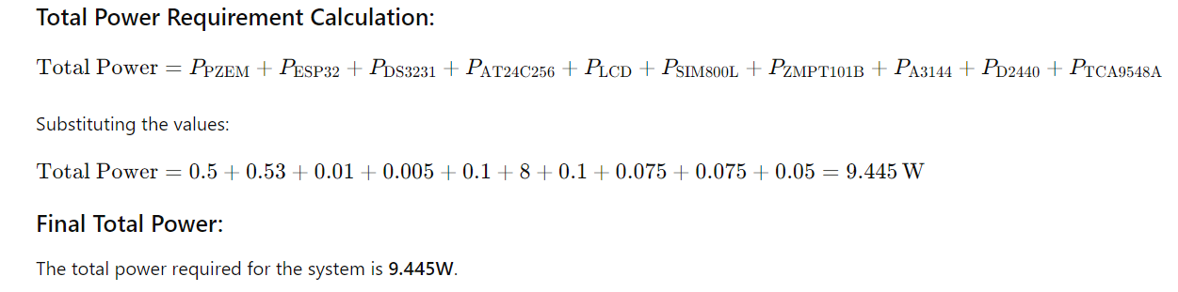

Power Requirement Table:
Module | Voltage(V) | Current(Amp) | Power(W)
PZEM-004T | 5 | 0.1 | 0.5
ESP32 WROOM 32 | 3.3 | 0.16 | 0.53
DS3231 | 5 | 0.002 | 0.01
AT24C256 | 5 | 0.001 | 0.005
20x4 LCD | 5 | 0.02 | 0.1
SIM800L | 4 | 2 | 8
ZMPT101B | 5 | 0.02 | 0.1
A1220 | 5 | 0.015 | 0.075
D2440-B | 5 | 0.015 | 0.075
TCA9548A | 5 | 0.01 | 0.05
Total | - | - | 9.445

On the basis of above power calculations of System we decided to use HLK-PM05 Hi-Link 5V 20W AC to DC Power Supply Module:

The HLK-PM05 is a compact and efficient AC to DC power supply module that converts 85-265V AC input to a regulated 5V DC output. This module is designed to provide reliable power for various electronic applications, making it ideal for powering low-power devices such as microcontrollers, sensors, and communication modules. With a high power density and small form factor, it is suitable for integration into smart energy metering systems and other compact electronic devices.

Specifications
Specification | Details
Input Voltage | 85-265V AC
Output Voltage | 5V DC
Output Current | 4A (max)
Output Power | 20W (max)
Efficiency | > 82%
Ripple Voltage | < 50mV
Operating Temperature | -40°C to +85°C
Size | 60mm x 36mm x 18mm
Weight | 60g
Protection Features | Short Circuit, Overload, Over Temperature Protection

